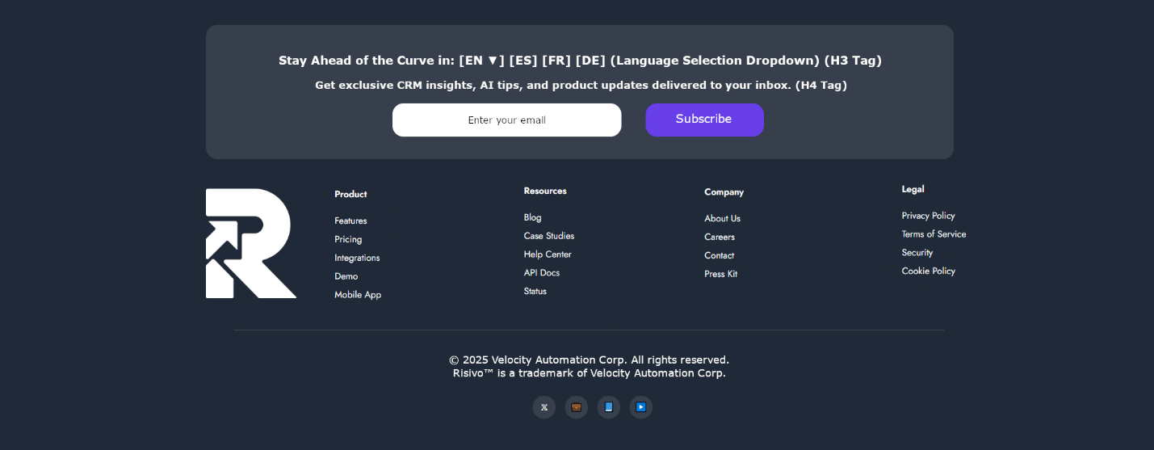
This is a mockup sketch of how I want the footer to look like. Of course, this is just a sketch so you have an idea of how I want it to look, but I rely on your UI/UX knowledge and capabilities to make it look professional and responsive for all devices.
Comments:
- I am also attaching the white icon for Risivo in the zip file “White Favicon.zip” so you can also upload it on the server for future usage on other dark areas (where required).
- Keep in mind that all 4 menus in the footer (Product, Resources, Company, and Legal) should be editable in the CMS admin once we start working on the CMS section.
- All contents should be aligned in the center of the footer vertically.
- Same padding/margin to separate the elements in the footer to look professional and nice looking.
- The social media icons at the bottom should all show the official icons of the corresponding social media, icons should be white and icon background light grey as it is in the sketch design. On hover, icons remain white but background changes to the brand purple color.
- Social media icons and links should also be managed in the CMS where we can add/delete/update social media channels.
Any questions or further suggestions, please let me know.

